MYTHICAL CREATUERS
MERMAIDS
One of the Greek mythical creatures are mermaids.
After the defeat of Uranus, Gaia mingled with her eldest son Ocean. Their children are the deities of the sea, rivers, lakes, and the liquid element in general.
According to mythology Children of Pontus and Gaia were Nereus, Miracle, Eurybia, Forkys and Keto. Forkis and Keto (brothers) "mixed" and gave birth to the three Grays, also Scylla and Charybdis, as well as the three Mermaids (Stheno, Evryali and Medusa).

It is said that they were Centaurs, who were transformed into abominable monsters by Athena, the patron saint of the city of Athens, because of Medusa. They are often associated with Sirens.

Mermaids
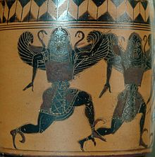
Forks and Keto parents
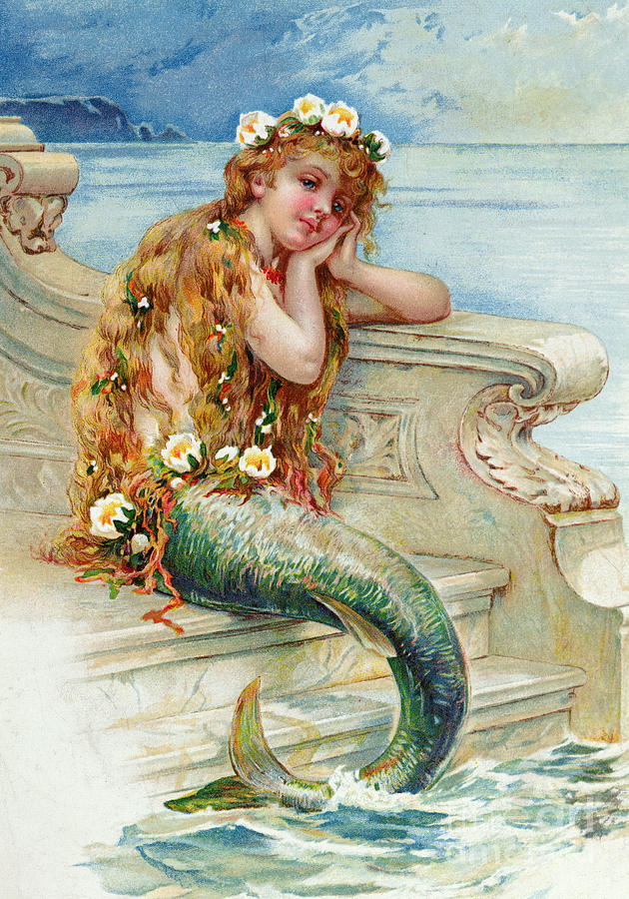
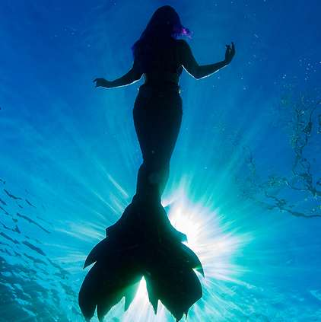
Brothers I Graies, Thosa, Echidna (probably), Ladon (probably) and Hesperides (probably)

