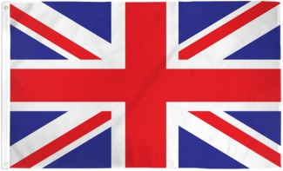
BRITISH VS AMERICA ENGLISH
BRITISH 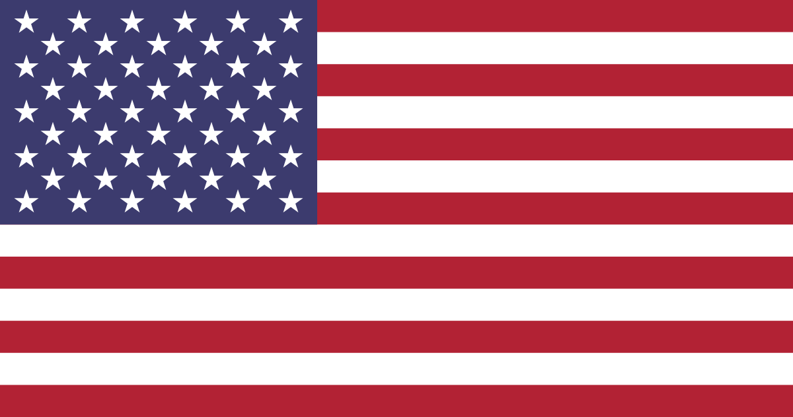 AMERICAN
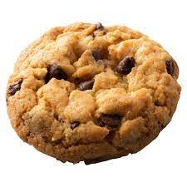
BISCUIT COOKIE

LORRY TRUCK

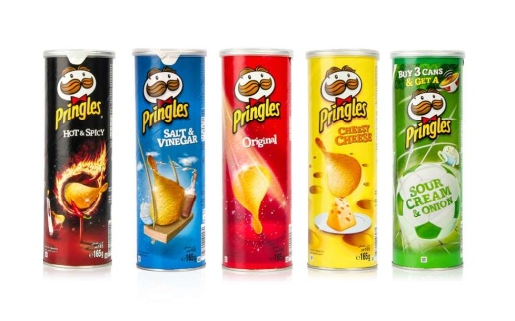
CRISPS CHIPS

FLAT APARTMENT

By Kyriakos Tsitsios

